IPV4-wireshark analysis
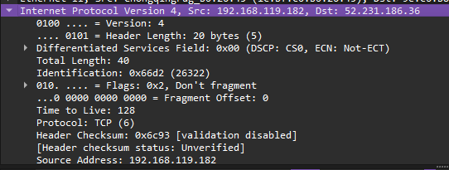
- Version(4 bits) → It means the IP version is 4 i.e. ipv4. If it was the version 6 then it would have shown the value 6 or 0110.
- Header Length : 20 bytes(5) → 4-byte words is present in header file and 5 represent the header is 20 bytes long (5*4 byte) → Each word represent 32 bit i.e. 1 word = 32 bit…….ipv4 consist 20 – 60 byte.
- Differentiated services code point(DSCP) → Real-time data streaming makes use of the DSCP field. It is a 6 bit field and it shows there is use of DSCP where value is b8.. 4)Explicit Congestion Notification (ECN) → This field allow end-to-end notification of network congestion without dropping packets. The value form the above picture says there is no use of ECN.
- Total Length(2 bytes): 52 → 52 byte of packet has been capture including the header for this case
4)Identification Number(2 byte) value:0x4bd9 indicate the identification value of this packet
5)Protocol: tcp(6) → This packet is described in form of tcp ip layer.
3)Header checksum (2 byte) ; value = 0x95fd→ It indicate the sent packets and received packets are same or not and If not same, the some data has been lost.
- source address(4byte); value =192.168.119.182 → It give the ip address of sender that indicate the address has been sent from the given address.
5)Destination address(4byte): value → It give the ip address of destination that indicate the address where the data is supposed to reach.
Notes::→ The IPv4 packet header consists of 14 fields(60 bytes), of which 13 are required(only 20 bytes are required)

